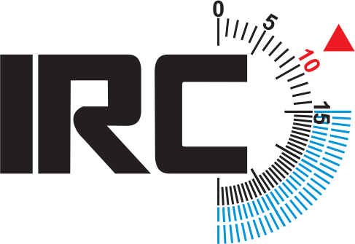
IRC – revalidate now
for the 2015 season – save late application fees
Your IRC certificate expired on 31 December. To enjoy a full year of great racing in 2015 please complete and return this form as soon as possible to: Rule Authority contact details here:

If you have made changes to the boat, please download & complete the ‘Reval Changes Form’ from our website, and attach it with your revalidation.

Please check the details below and let us know any changes:

Owner name |  |  | Boat name
Address |  |  | Sail no.
 |  |  | Cert no.
POST TOWN |  |  | Design
Post Code |  |  | Day tel.
Country |  |  | Mobile tel.
We will send your certificate to this email address:
Usual racing area (eg. S.Wales, Brighton)
Current RORC membership no.if applicable
Data Protection:. If you DO NOT wish to receive IRC related information from third parties, please put a X here :

Please place an X in one box below: |  |  |  | X here
- I have made NO CHANGES to the boat since the last valid IRC certificate
b) I have made CHANGES to the boat since the last valid IRC certificate (tell us now to avoid an amendment fee!) Please give brief summary below and enter the details on a ‘Reval Changes Form’. If you need an Endorsed certificate then measurement may be required, please contact us for advice. For sails also see the question below.
SAILS: If you have bought new (largest) sails since your last valid certificate or you have them on order, we need to be told even if the size(s) are designed to be the same as before. If you need Endorsement official measurement will be required, please contact us for advice if necessary.
New sails for 2015? Y / N |  | Sail loft name

DECLARATION: I confirm that information supplied is correct to the best of my knowledge, and that I have read the current IRC Class Rules and agree to comply with them in full. ONE DESIGNS: I declare that the above yacht complies entirely with the current One Design Class Rules for this design and holds a valid class certificate.

www.ircrating.org

